**Development Phase**

**Sprint - 3**

|  |  |
| --- | --- |
| Date & Team ID | 19 November 2022 &  PNT2022TMID47097 |
| Project Name | Deep Learning Fundus Image Analysis for Early Detection of Diabetic Retinopathy |

# Sprint Plan

Define the initial stages of the problem requirement.

Draw and understand the flowchart of the sprint

Assign tasks to each teammate

# Team Tasks

* Connecting to database
* Doctor uses this report for seeing patient’s activity

# Progress

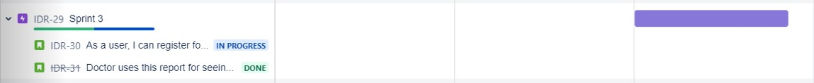

# Sprint tracker

start date end date current sprint points

07 Nov 2022 12 Nov 2022 18

**Velocity for Sprint-3 = 20/8 = 2.5**

# Code Snippet

# Authenticate using an IAM API key

client = Cloudant.iam('d3ffc21a-c9d1-4276-a7c3-d7a48a949e1f-bluemix', 'oS6rF9Lb8-d8IyJW4VEdHx5kiIN9ehQnNoj8ygKXFjzu', *connect*=True)

|  |
| --- |
| # Create a database using an initialized client my_database = client.create_database('my_db') if my_database.exists():  print("Database '{0}' successfully created.".format('my_db')) |

# Test cases

|  |  |
| --- | --- |
| **Test cases** | **Result** |
| Upload and correct prediction | Successful (logged in as abc@gmail.com) |
| Viewing prediction | Successful |
| Database Creation | Successful |
| Store data in as a json query | Success |

# Result

